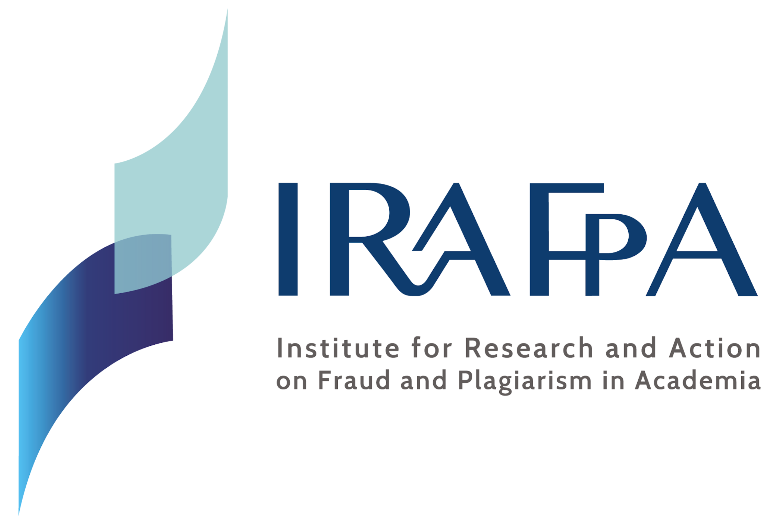

International Institute for Research and Action on Fraud and Plagiarism in Academia

6th IRAFPA International Colloquium on Academic Integrity

How can we design doctoral programmes that enable students to develop a strong identity as ethical researchers?

Online, Thursday 17 – Friday 18 June 2027

Registration Form (1 per person)

Required fields (the first 5 will appear in the Colloquium programme)

Title (Mr./Mrs./...): ________________________________________

First name: ________________________________________

Last name: ________________________________________

Position or title: ________________________________________

Institution/Organization: ________________________________________

________________________________________

Participant's contact address, country: ________________________________________

Email: ________________________________________

Phone: ________________________________________

Registration type:

Please indicate your type of registration, amount and currency.

☐ Attendee. Free of charge.
Registration is required to receive your personalized access code before the Colloquium. No invoice will be issued.

☐ Presenter 100 EUR (or 110 CHF): _________
Includes annual IRAFPA membership. Once the registration form is received, bank details will be sent to proceed with payment.
For invoicing: full name and address of the invoice recipient (if different from the participant's):

________________________________________

________________________________________

Please return the completed form to:
Prof. Michelle Bergadaa, michelle.bergadaa@responsable-academia.org

